Amoskeag Health

2024-2025 Community Needs Assessment

A Community Profile and Strategic Assessment for Amoskeag Health
Manchester, New Hampshire

Executive Summary
Manchester, New Hampshire is the state's largest urban center and one of its most diverse communities. As the population continues to evolve, many residents experience significant social, economic, and health-related challenges that influence their overall well-being and ability to access care. While Manchester benefits from a strong network of healthcare providers, nonprofit organizations, educational institutions, and community resources, persistent disparities in housing stability, behavioral health, economic security, educational outcomes, and access to preventive services continue to affect many individuals and families.
As the region's federally qualified health center (FQHC), Amoskeag Health is committed to understanding the needs of the community it serves and ensuring that its programs, services, and strategic priorities remain responsive to changing community conditions. This Community Needs Assessment (CNA) provides a comprehensive review of demographic trends, health indicators, community areas of need, and stakeholder perspectives to identify the most pressing health needs facing Manchester residents. As the region's Federally Qualified Health Center, Amoskeag Health addresses community health through an integrated model of care that combines primary care, behavioral health, oral health, enabling services, and community partnerships to reduce barriers and improve health equity.
The assessment integrates quantitative data from federal, state, and local sources with qualitative information gathered through patient and employee focus groups, community surveys, and interviews with healthcare providers, nonprofit leaders, public officials, and community partners. Together, this data provides a comprehensive understanding of the factors influencing health outcomes across Manchester.
Several key themes emerged throughout the assessment:
- Housing affordability and homelessness continue to place many individuals and families at increased risk for poor health outcomes.
- Behavioral health and substance use disorders remain significant concerns, with continued demand for accessible, integrated mental health and recovery services.
- Economic insecurity persists despite relatively low unemployment rates, as many households struggle with the rising costs of housing, childcare, transportation, food, and healthcare.
- Educational disparities continue to affect children and adolescents, particularly among specific populations, contributing to long-standing barriers in health and economic opportunity.
- Manchester's growing racial, ethnic, and linguistic diversity highlights the importance of culturally responsive care, language access, and universal healthcare delivery.
- Workforce shortages across healthcare and human service sectors continue to challenge timely access to care and community support services.
These findings reinforce that health is influenced by far more than access to medical care alone. Stable housing, educational opportunity, economic security, transportation, food access, behavioral health, and community connectedness all contribute to individual and population health outcomes. Addressing these interconnected factors requires continued collaboration among healthcare providers, public health agencies, schools, nonprofit organizations, local government, and community members. The findings of this assessment will guide Amoskeag Health's strategic planning and community partnerships over the coming years. By continuing to deliver comprehensive, responsive, and integrated care, while addressing community areas of need, Amoskeag Health remains committed to improving health outcomes and advancing health equity for all members of the Manchester community.

Table of Contents
Executive Summary .......................................................................2
Introduction ...................................................................................5
Community Profile ........................................................................8
Community Assets .........................................................................9
Understanding the Population We Serve.....................................11
Population Needs & Community Areas of Need ................................................................12
Health Status & Population Health .............................................16
Community Partnerships .............................................................23
Conclusion .................................................................................... 24
Appendices ................................................................................... 25
Appendix A. Demographic & Population Profile
Appendix B. Education
Appendix C. Economic Stability & Food Security
Appendix D. Housing & Transportation
Appendix E. Health Indicators
Appendix F. Community Safety
Appendix G. Amoskeag Health Patient Population

Introduction
This Community Needs Assessment examines the health needs, strengths, and challenges affecting Manchester, New Hampshire, and the patients served by Amoskeag Health. The assessment combines quantitative data from local, state, federal, and organizational sources with qualitative input from patients, employees, community partners, and community leaders to identify the factors that most influence health and well-being.
The report is organized around the major populations served by Amoskeag Health and the areas of need that shape community well-being. Detailed data tables, charts, and supporting analyses are provided in the appendices to allow the narrative to focus on key findings, emerging trends, and their implications for the community and Amoskeag Health.
The findings presented in this assessment are intended to support strategic planning, strengthen community partnerships, guide program development, and advance health equity throughout the Greater Manchester community.

About Amoskeag Health
Amoskeag Health is Manchester's federally qualified health center (FQHC) and a leading provider of comprehensive, community-based healthcare services for individuals and families throughout Greater Manchester. Through integrated primary care, behavioral health, dental services, obstetrics and gynecology, pediatrics, pharmacy, case management, and enabling services, the organization delivers coordinated, patient-centered care designed to improve health outcomes and reduce barriers to care.
Serving more than 15,000 patients annually, Amoskeag Health provides care regardless of a person's ability to pay and works closely with hospitals, schools, public health agencies, and community organizations to address the medical, behavioral, and community areas of need. As one of the region's primary safety net providers, the organization is committed to advancing health equity, improving access to culturally responsive care, and strengthening the overall health of the communities it serves.
This Community Needs Assessment supports that mission by identifying the health needs, assets, and priorities of the Manchester community and providing a framework to guide organizational planning, partnerships, and future investments in community health.

Community Needs Assessment Methodology
Understanding a community's health requires more than reviewing statistics alone. While quantitative data provide valuable information about population trends and health indicators, they do not fully capture the experiences, perspectives, and priorities of the people who live and work in the community. For this reason, Amoskeag Health utilized a mixed-methods approach that combined quantitative data with qualitative input from patients, employees, community partners, and local leaders to develop a comprehensive understanding of Manchester's health needs.
The Community Needs Assessment was conducted over an 18-month period during 2023 and 2024 to examine the health status of Manchester residents, identify emerging community needs, understand barriers to health and healthcare, and inform Amoskeag Health's strategic planning. The assessment sought to answer two fundamental questions:
- Who is the Manchester community, and how is it changing?
- What are the greatest opportunities for improving the health and well-being of the individuals and families Amoskeag Health serves?
By integrating community voices with objective health and demographic data, the assessment provides a more complete picture of the social, economic, and environmental factors that influence health throughout Manchester.

Qualitative Data Collection
Community engagement was a central component of the assessment process. Amoskeag Health actively sought input from individuals representing a broad range of perspectives, including patients, employees, healthcare providers, nonprofit organizations, community leaders, funders, and local government. Multiple engagement strategies were used to ensure that the assessment reflected both lived experiences and professional expertise.
Qualitative information was collected through:
- Patient Focus Groups: Five virtual focus groups conducted in English, Spanish, Arabic, and Nepali with 15 participants.
- Employee Focus Groups: One virtual focus group (13 participants) and one in-person focus group (10 participants).
- Employee Survey: Anonymous survey completed by 82 employees.
- Patient Survey: Community survey completed by 204 patients.
- Community Partner Survey: Survey distributed to nonprofit organizations, managed care organizations, City departments, business leaders, funders, and other community partners.
- Stakeholder Interviews: Eighteen interviews conducted with healthcare leaders, nonprofit organizations, elected officials, funders, and other community stakeholders.
These conversations provided valuable insight into community strengths, emerging challenges, service gaps, and opportunities for collaboration. Participants consistently emphasized that health is influenced by a broad range of factors extending beyond medical care, including housing, transportation, education, behavioral health, economic stability, food security, and access to culturally responsive services.

Quantitative Data Collection
Quantitative data were compiled from federal, state, local, and organizational sources to provide an objective assessment of Manchester's population characteristics, health outcomes, and community areas of need. Data sources included the U.S. Census Bureau, American Community Survey, New Hampshire Department of Health and Human Services, New Hampshire Department of Education, City Health Dashboard, County Health Rankings, the U.S. Bureau of Labor Statistics, Manchester Public Health, and Amoskeag Health's Uniform Data System (UDS) and other organizational data.
Together, these data describe demographic trends, economic conditions, educational outcomes, housing stability, food insecurity, behavioral health, access to care, and other factors that influence the health of Manchester residents. Whenever possible, the assessment incorporates both community-wide indicators and Amoskeag Health patient data to provide a clearer understanding of the population served by the organization.

Using the Findings
No single organization can address the complex factors that shape community health. The findings presented throughout this assessment are intended to guide strategic decision-making, strengthen partnerships, and identify opportunities for collective action across Manchester.
The information gathered through this assessment directly informed Amoskeag Health's strategic planning process and will continue to guide organizational priorities, program development, community partnerships, and resource allocation over the next three years. By combining community voices with objective data, Amoskeag Health is better positioned to respond to evolving community needs while advancing health equity and improving access to comprehensive, culturally responsive care.

Community Profile
Figure 1. Manchester and Amoskeag Health at a Glance

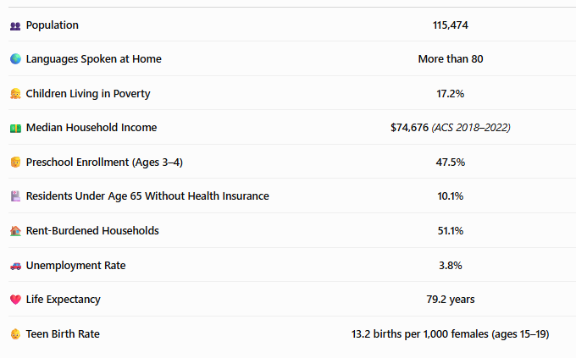

Community data above are derived from federal, state, and local public data sources. Amoskeag Health data are from the 2024 Uniform Data System (UDS) and Community Needs Assessment engagement activities.

Community Description
Manchester, New Hampshire, is the state's largest city and serves as the economic, healthcare, educational, and cultural center of southern New Hampshire. Located in Hillsborough County along the Merrimack River, Manchester functions as the regional hub for employment, healthcare, transportation, higher education, and social services. As one of only two county seats in Hillsborough County, Manchester attracts residents, workers, students, and visitors from throughout the region.
Unlike many New Hampshire communities, Manchester is characterized by its urban environment, increasing racial and ethnic diversity, and concentration of refugee and immigrant populations. The city is home to individuals and families representing dozens of countries and languages, creating a vibrant multicultural community while also increasing the need for responsive healthcare, language access services, and community-based support systems.
As the region's federally qualified health center, Amoskeag Health serves patients from across Manchester and surrounding communities. Many patients face complex medical and social needs influenced by economic hardship, housing instability, behavioral health conditions, transportation barriers, food insecurity, and limited access to preventive healthcare. Understanding these interconnected factors is essential to designing programs and services that effectively improve community health.

Demographic Overview
Amoskeag Health's primary service area is the City of Manchester, New Hampshire, located within Hillsborough County. The organization's geographic catchment area includes several neighborhoods commonly referred to as the "Center City," where many of Manchester's lowest-income and most racially and ethnically diverse residents live. These neighborhoods include Census Tracts 13, 14, 15, 16, 19, and 2004 on the east side of the Merrimack River, and Census Tracts 20, 21, and 22 on the west side.
These neighborhoods experience higher rates of poverty, housing instability, food insecurity, chronic disease, and other areas of need than many surrounding communities. Concentrating services within these areas enables Amoskeag Health to improve access to comprehensive primary care, behavioral health, oral health, prenatal care, pediatric services, and community-based supports for populations experiencing the greatest health disparities.

Community Assets
Despite significant health and socioeconomic challenges, Manchester benefits from numerous community strengths that contribute to residents' quality of life and overall well-being.

Transportation
Manchester's transportation network provides access to employment, education, healthcare, and recreational opportunities throughout southern New Hampshire. The Manchester Transit Authority (MTA) operates fixed-route bus service throughout the city and connects residents with neighboring communities including Nashua, Concord, and the Seacoast. The Green DASH shuttle provides free transportation through downtown Manchester, improving access to businesses, government offices, healthcare facilities, and community services.
The Manchester-Boston Regional Airport serves as one of northern New England's major transportation hubs, supporting both passenger travel and commercial freight while contributing significantly to the regional economy.

Access to Health Care
Access to affordable, timely healthcare is essential for preventing disease, managing chronic conditions, and improving overall health outcomes. While Manchester benefits from a strong network of healthcare providers, barriers such as lack of insurance, cost, transportation, and other community areas of need can delay or prevent individuals from receiving needed care.
In 2023, an estimated 10.1% of Manchester residents under age 65 were uninsured, creating potential barriers to preventive services, chronic disease management, and timely medical treatment. Improving access to affordable, comprehensive healthcare remains an important community priority. Additional healthcare access indicators are provided in Appendix G, Tables G1-G4.

🩺 How Does Amoskeag Health Respond?

Amoskeag Health improves access to care by providing comprehensive primary care regardless of a patient's ability to pay. Through a Sliding Fee Discount Program, insurance enrollment assistance, and care coordination services, patients receive help obtaining health coverage, navigating community resources, and accessing affordable medical, behavioral health, oral health, and supportive services. By reducing financial and other barriers to care, Amoskeag Health helps ensure that all members of the community have access to high-quality, integrated healthcare.

Community Connections
Manchester offers a diverse array of cultural, recreational, and educational opportunities that contribute to community vitality.
Residents enjoy professional sporting events through the New Hampshire Fisher Cats at Delta Dental Stadium, concerts and family entertainment at SNHU Arena, and live theatrical performances at the historic Palace Theatre. Museums including the SEE Science Center, Currier Museum of Art, Millyard Museum, and Amoskeag Fishways provide educational and cultural experiences for residents of all ages.
These institutions not only enhance quality of life but also strengthen community engagement, social connectedness, and opportunities for lifelong learning.

Business and Economic Environment
Manchester serves as one of New Hampshire's primary economic engines. The city's economy is supported by more than 6,000 commercial establishments representing diverse industries including healthcare, advanced manufacturing, information technology, aerospace and defense, financial services, retail, biotechnology, and education.
Its central location, transportation infrastructure, and skilled workforce continue to attract employers and support regional economic growth. At the same time, rising housing costs, workforce shortages, and increasing costs of living present ongoing challenges for employers and residents alike.

Why This Matters
Manchester's unique demographic, economic, and cultural characteristics distinguish it from much of New Hampshire and directly influence the health needs of its residents. The city's diversity, urban environment, and concentration of social and economic challenges create both opportunities and responsibilities for healthcare providers.
For Amoskeag Health, understanding these community characteristics is essential for developing responsive, equitable, and culturally competent programs that address both clinical needs and the broader community areas of need. This assessment provides the foundation for identifying community priorities and guiding organizational planning over the coming years.

Understanding the Population We Serve

Patient Service Area
Although Amoskeag Health's primary service area is the City of Manchester, the organization provides care to patients from communities throughout southern and central New Hampshire. During the 2024 UDS reporting period, Amoskeag Health served 15,359 patients residing in dozens of ZIP codes across the region. Most patients resided within Manchester ZIP codes, particularly 03103 (5,830 patients), 03102 (3,159 patients), and 03104 (2,722 patients), demonstrating the organization's strong presence in the city's largest residential neighborhoods. Additional concentrations of patients lived in Manchester ZIP codes 03101 and 03109, while substantial numbers traveled from neighboring communities including Hooksett, Bedford, Londonderry, Concord, and surrounding towns.
This broad geographic distribution illustrates Amoskeag Health's role as both Manchester's federally qualified health center and a regional provider of primary care, behavioral health, prenatal, pediatric, and enabling services. While many patients can access care using Manchester's public transportation system, individuals traveling from outside the city often rely on personal vehicles, family support, Medicaid transportation, or other transportation resources, emphasizing the importance of maintaining geographically accessible clinic locations and coordinated transportation options.
Amoskeag Health serves patients from throughout southern New Hampshire; however, the majority reside within Manchester, particularly in ZIP Codes 03103, 03102, and 03104 (Appendix G, Table G4).

Language Access & Population Responsiveness
Optimal health exists for the entire population when every individual can achieve their highest level of health, regardless of their circumstances. While Manchester continues to grow as one of New Hampshire's most diverse communities, not all residents experience the same opportunities to achieve optimal health. Differences in income, educational attainment, housing stability, transportation, health literacy, and access to culturally responsive services contribute to persistent challenges in health outcomes and healthcare access.
Manchester is home to residents representing dozens of countries, cultures, and languages. Approximately 21% of Manchester residents speak a language other than English at home, compared with 8% statewide, underscoring the importance of culturally responsive care and language access services. Additional language and demographic indicators are provided in Appendix G, Tables G1-G4. This diversity strengthens the community but also highlights the importance of healthcare services that are population responsive, linguistically appropriate, and accessible to all individuals. Patients with limited English proficiency, recent immigrants and refugees, and individuals navigating unfamiliar healthcare systems may experience additional barriers to receiving timely and effective care. Addressing these barriers is essential to improving communication, building trust, promoting preventive care, and advancing health equity throughout the community.

🌎 How Does Amoskeag Health Respond?
Manchester is home to one of New Hampshire's most culturally and linguistically diverse populations, and Amoskeag Health is committed to providing patient-centric responsive care for every patient. The organization employs dedicated in-house interpreters for many of the languages most commonly spoken by its patients and provides on-demand interpretation services for hundreds of additional languages through secure video (iPad) and telephone interpretation services. Combined with multilingual staff and culturally responsive care practices, these services help reduce language barriers, improve communication, and ensure that patients can fully participate in decisions about their healthcare.

Population Needs & Community Areas of Need

Although each population experiences unique health challenges, several themes emerged consistently throughout the assessment. Housing affordability, behavioral health, economic stability, transportation, food insecurity, and access to culturally responsive healthcare affect residents across every age group. These issues are closely interconnected and reinforce the importance of coordinated strategies that address both clinical care and the community areas of need.

Children & Youth
Children and adolescents represent one of Manchester's most important populations because experiences during childhood shape lifelong health, educational achievement, and economic opportunity. While many children in Manchester thrive, others experience challenges related to poverty, housing instability, food insecurity, educational disparities, and behavioral health needs. These interconnected factors influence physical, emotional, and developmental well-being and highlight the importance of early intervention and coordinated community supports.
As the region's Federally Qualified Health Center, Amoskeag Health plays a vital role in supporting children and families through comprehensive pediatric care, prenatal services, behavioral health, oral health, school-based partnerships, and programs that address the community areas of need. The following sections examine the key factors influencing the health and well-being of Manchester's children and families.

Education
Education is one of the strongest predictors of lifelong health and well-being. Children who have access to high-quality early childhood education, regularly attend school, and graduate from high school are more likely to experience better health outcomes, higher lifetime earnings, and greater economic stability. Educational achievement is intricately connected to many of the community areas of need, including housing stability, food security, family income, and access to healthcare.
Manchester Public Schools serve a diverse student population and continue to provide educational opportunities for thousands of children each year. However, educational indicators demonstrate persistent disparities across racial and ethnic groups. Fewer than half of Manchester's three- and four-year-old children are enrolled in preschool, and kindergarten enrollment remains below pre-pandemic levels, limiting early learning opportunities for many children. These early educational experiences are critical for school readiness and long-term academic success.
As students progress through school, disparities become increasingly evident. Chronic absenteeism remains particularly high among Hispanic and Black students, affecting more than half of Hispanic students (55.8%) and nearly one-third of Black students (30.0%), compared with 18.5% of Asian students and 21.6% of White students. High school completion rates also vary, with White and Asian students graduating at substantially higher rates than Hispanic and Black students. Similar disparities are reflected in English Language Arts proficiency, where White and Asian students consistently outperform their Hispanic and Black peers. (See Appendix B, Tables B1-B2 for detailed education indicators).
These findings demonstrate that educational disparities begin early and continue throughout childhood, reflecting the influence of broader social and economic conditions. Factors such as housing instability, poverty, transportation barriers, language differences, food insecurity, and access to early childhood education all contribute to educational outcomes. Addressing these disparities will require continued collaboration among schools, healthcare providers, community organizations, and families to ensure that every child can succeed academically and achieve optimal health throughout their lifetime.
🎓 How Does Amoskeag Health Respond?

Amoskeag Health recognizes that educational achievement is influenced by both physical and behavioral health. Through comprehensive pediatric care and behavioral health clinicians embedded throughout Manchester School District schools, the organization brings services directly to students, reducing barriers to care and supporting mental health, school attendance, and academic success. This integrated approach helps children receive timely care in familiar settings while strengthening partnerships among families, schools, and healthcare providers.

Housing
Stable housing provides children with the foundation necessary for healthy growth, learning, and emotional well-being. Families experiencing housing instability often face frequent moves, overcrowding, financial stress, and disruptions in healthcare and education. These challenges can negatively affect school attendance, academic performance, behavioral health, and long-term health outcomes.
Manchester continues to experience increasing housing costs and limited availability of affordable housing, placing many families with children at risk of housing instability or homelessness. Children experiencing unstable housing are more likely to miss school, experience chronic health conditions, and require additional educational and behavioral health supports. As housing affordability continues to decline, collaboration among healthcare providers, housing agencies, schools, and community organizations will remain essential to helping families maintain stable housing and reducing the long-term effects of housing instability on child health and development.

Food Insecurity
Food security is a fundamental component of health and well-being. Reliable access to nutritious food supports healthy growth and development, chronic disease management, and overall physical and mental health. When individuals and families lack consistent access to healthy food, they are at increased risk for poor health outcomes, higher healthcare utilization, and reduced quality of life.
Food insecurity continues to affect many Manchester residents despite the community's extensive network of food assistance programs. Approximately 46% of Manchester students qualify for free or reduced-price school meals, reflecting the ongoing economic challenges faced by many local families. At the state level, New Hampshire experienced a 43.9% increase in food insecurity, with more than 135,000 residents experiencing food insecurity according to Feeding America's 2024 report. Local organizations have also reported increasing demand for nutrition assistance, including expanded food delivery services for older adults. Additional food security indicators are provided in Appendix C.
🍎 How Does Amoskeag Health Respond?
Amoskeag Health recognizes that access to nutritious food is essential to achieving positive health outcomes. Patients experiencing food insecurity relate to community food resources and nutrition assistance through comprehensive care coordination and case management services. To address immediate needs, every Amoskeag Health clinic maintains an emergency food pantry, ensuring patients and families have access to food when they need it most. By integrating food security into whole-person care, Amoskeag Health helps reduce barriers to health while connecting patients with long-term community supports.

Community Safety
Community safety is an important community area of need that influences physical well-being, mental health, and overall quality of life. Safe neighborhoods encourage physical activity, social connection, educational success, and healthy development, while exposure to crime, violence, and traumatic events can contribute to chronic stress, anxiety, depression, and adverse childhood experiences. As a result, community safety plays an important role in shaping both individual and population health outcomes.
According to the 2022 Greater Manchester Community Health Needs Assessment, Manchester reported a violent crime rate of 494 per 100,000 residents and a property crime rate of 2,501 per 100,000 residents. Community data also indicate that 8% of high school students reported experiencing physical dating violence, highlighting the importance of prevention efforts, trauma-informed care, and coordinated community responses that support the safety and well-being of children, families, and neighborhoods. Additional community safety indicators are provided in Appendix F, Table F1 and Figure F1.

🤝 How Does Amoskeag Health Respond?
Amoskeag Health recognizes that exposure to violence and traumatic events can have lasting effects on physical and behavioral health. Through its partnership with the Manchester Police Department and YWCA New Hampshire as part of the Adverse Childhood Experiences Response Team (ACERT), families experiencing traumatic events involving law enforcement receive timely outreach, warm referrals, and connections to behavioral health and community support services. This trauma-informed approach helps reduce the long-term impacts of adverse childhood experiences while strengthening collaboration between healthcare, public safety, and community partners.

Health Status and Population Health

Maternal, Child & Family Health
Healthy pregnancies and positive birth outcomes establish the foundation for lifelong health and development. Early access to prenatal care, postpartum support, and pediatric services contributes to healthier mothers, healthier infants, and stronger families. In Manchester, 7.5% of infants are born with low birthweight, and 67.6% of pregnant individuals receive prenatal care during the first trimester, highlighting the importance of continued efforts to promote healthy pregnancies, early intervention, and access to maternal and infant health services. (See Appendix E, Table E5.)

👶 How Does Amoskeag Health Respond?
Amoskeag Health supports children, adolescents, and families through comprehensive maternal, obstetric, pediatric, and family-centered care that promotes healthy development across every stage of life. Through its Maternal Health & Obstetrics Department, the organization provides comprehensive prenatal care and delivers babies, ensuring families receive coordinated care throughout pregnancy, childbirth, and the postpartum period. Through its Personal Responsibility Education Program (PREP), adolescents receive evidence-based education, skills, and tools to make informed decisions about healthy relationships, personal responsibility, and sexual health. For families welcoming a new baby, the Ready Set Launch program provides free home visits to every Manchester family with a newborn delivered at Elliot Hospital, offering education, developmental guidance, connections to community resources, and early support during a child's critical first months of life. Together, these services support healthy pregnancies, positive birth outcomes, and strong starts for children and families throughout the Manchester community.

Adults & Families
Adults represent the largest segment of Manchester's population and are the economic, social, and caregiving foundation of the community. Their health and well-being influence the stability of families, the strength of the workforce, and the overall vitality of Manchester. While many adults enjoy good health, others face challenges related to financial insecurity, housing affordability, transportation barriers, behavioral health, and access to affordable healthcare.
As Manchester's Federally Qualified Health Center, Amoskeag Health provides comprehensive, integrated care that addresses both medical needs and the community areas of need. The following sections examine the key factors affecting the health and well-being of Manchester's adult population and the strategies that help improve access to care and promote health equity.

Economic Stability
Economic stability is one of the strongest predictors of health and influences an individual's ability to obtain housing, nutritious food, transportation, childcare, medications, and preventive healthcare. While employment provides an important pathway to financial security, employment alone does not guarantee economic stability. Many Manchester residents continue to experience financial hardship despite working full-time, reflecting the growing gap between wages and the cost of living.
Although unemployment in Manchester has remained relatively low in recent years, inflation and increasing housing, childcare, transportation, and healthcare costs have placed additional financial strain on many households. Families with lower incomes are disproportionately affected by these rising costs and often face difficult decisions regarding basic necessities, healthcare, and other essential expenses.
Economic insecurity is also associated with increased stress, poorer mental health, delayed healthcare, chronic disease, and reduced life expectancy. Strengthening workforce opportunities while expanding access to affordable housing, childcare, transportation, and healthcare remains essential to improving community health.

Poverty
Poverty continues to affect thousands of Manchester residents and remains one of the strongest predictors of poor health outcomes. Although economic conditions have improved in recent years, many individuals and families continue to struggle to meet basic needs. According to the American Community Survey, 10.6% of Manchester residents and 17.2% of children live below the federal poverty level. Poverty disproportionately affects children, single-parent households, and communities of color, contributing to disparities in housing stability, food security, educational attainment, and access to healthcare. (See Appendix C, Table C1 for additional poverty and economic indicators).
Poverty influences nearly every other community health issue identified in this assessment. Families experiencing economic hardship are more likely to experience food insecurity, unstable housing, transportation barriers, delayed healthcare, and chronic stress. These findings reinforce the importance of coordinated strategies that address both medical needs and the underlying community areas of need.
💲 How Does Amoskeag Health Respond?
Amoskeag Health serves a patient population with significant economic need. In 2024, 63.6% of patients had household incomes at or below 200% of the Federal Poverty Guidelines, underscoring the importance of providing affordable, comprehensive healthcare and connecting patients with services that address the community areas of need.

Housing Stability
Access to safe, stable, and affordable housing is one of the most important factors influencing health and well-being. Housing affects physical and behavioral health, financial stability, educational achievement, and access to employment and healthcare. Individuals and families experiencing housing instability are more likely to delay medical care, experience food insecurity, struggle with chronic disease management, and face increased stress and behavioral health challenges.
Housing affordability continues to be a significant challenge in Manchester. In 2023, 51.1% of renter households were considered rent burdened, spending at least 30% of their household income on housing costs. As housing costs continue to rise, many residents face difficult choices between paying for housing, healthcare, food, transportation, and other necessities.
Housing instability also contributes to homelessness within the community. The 2023 Point-in-Time Count identified 538 individuals experiencing homelessness in the Manchester Continuum of Care, including 124 individuals (23%) who were unsheltered. These data highlight the continuing need for affordable housing, supportive services, and coordinated community efforts that help individuals and families achieve and maintain stable housing. (See Appendix D, Table D1 and Figures D1-D2).

🏠 How Does Amoskeag Health Respond?
Stable housing is fundamental to good health. Amoskeag Health recognizes that housing instability can affect a patient's ability to manage chronic conditions, attend medical appointments, maintain employment, and meet other basic needs. Through comprehensive care coordination and case management services, patients are screened for housing-related needs and connected with emergency assistance, affordable housing resources, and community support services. Amoskeag Health also works closely with Healthcare for the Homeless, Manchester's Federally Qualified Health Center serving individuals experiencing homelessness, to support care coordination, facilitate referrals, and help patients establish a medical home, and connect with supportive services. By addressing housing as part of whole-person care and collaborating with community partners, Amoskeag Health helps reduce barriers to health while promoting greater stability and improved health outcomes for individuals and families.

Behavioral Health
Behavioral health is an essential component of overall health and well-being and affects individuals across the lifespan. Mental health conditions and substance use disorders can influence physical health, employment, educational attainment, family stability, and quality of life. Timely access to prevention, early intervention, treatment, and recovery services is critical to improving health outcomes and reducing disparities.
In 2022, an estimated 18.2% of Manchester adults reported experiencing frequent mental distress, exceeding the average among City Health Dashboard communities (17.1%). Manchester continues to experience the effects of the opioid crisis, although recent data suggest a decline in opioid-related overdoses following peaks in previous years. Continued investment in prevention, treatment, harm reduction, and recovery services remains essential. Additional behavioral health and substance use indicators are provided in Appendix E, Tables E2 and Figures E1-E3.
Expanding access to integrated behavioral health services, strengthening community partnerships, and increasing prevention, early intervention, treatment, and recovery supports remain essential to improving health outcomes across Manchester.

🧠 How Does Amoskeag Health Respond?

Amoskeag Health integrates behavioral health services within its primary care practices, making mental health care more accessible and reducing barriers to treatment. Through outpatient counseling, psychiatric services, substance use treatment, school-based behavioral health programs, and close collaboration with community partners, Amoskeag Health provides coordinated, whole-person care that supports the emotional and physical well-being of patients across the lifespan.

Transportation Access
Transportation is a critical community area of need that influences an individual's ability to access healthcare, employment, education, and other essential services. Although most New Hampshire residents commute by personal vehicle, transportation options are not equally available to all populations. Individuals who rely on public transit experience substantially longer commute times than those traveling by private vehicle, and public transportation is more commonly used by renters, lower-income workers, younger adults, and racial and ethnic minority populations. Vehicle ownership further illustrates these disparities. Renter households are considerably more likely than homeowners to have limited or no access to a personal vehicle, increasing reliance on public transportation, shared vehicles, or assistance from family and friends for essential travel, including medical appointments. Rising transportation costs may further compound these challenges for households already experiencing financial hardship.
🚌 How Does Amoskeag Health Respond?
Transportation is a recognized community area of need that can affect an individual's ability to obtain preventive care, manage chronic conditions, and keep medical appointments. By operating four clinical sites strategically located throughout Manchester and accessible by Manchester Transit Authority (MTA) bus routes, Amoskeag Health helps reduce transportation barriers and improve equitable access to comprehensive healthcare services for the communities it serves.
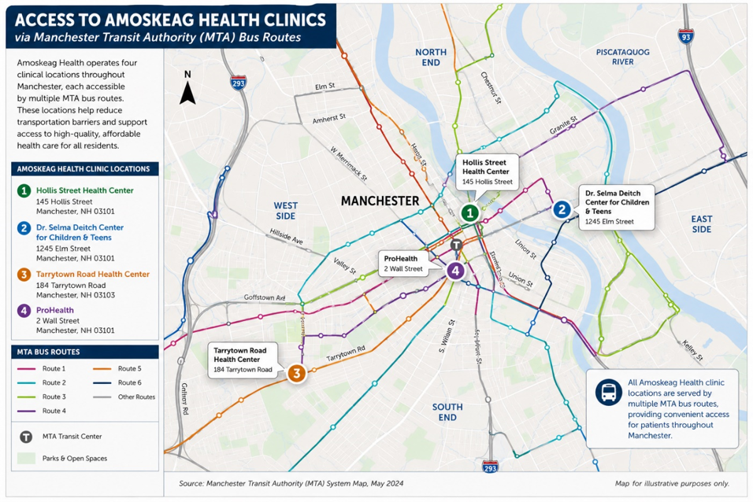
Figure 2. Amoskeag Health clinic locations and Manchester Transit Authority (MTA) bus routes serve each site.
Amoskeag Health's four Manchester clinic locations are strategically distributed throughout the city and are accessible by multiple MTA bus routes, helping reduce transportation barriers and improve access to primary care, behavioral health, dental, pediatric, and specialty services.

Additional transportation indicators are provided in Appendix D, Table D2.

Oral Health
Access to oral health is an important metric for overall health and well-being, influencing nutrition, speech, child development, chronic disease management, and quality of life. Untreated dental disease can lead to pain, infection, missed school and work, and increased use of emergency departments for preventable conditions. Access to preventive dental care, early intervention, and oral health education are critical to maintaining lifelong health.
Despite the importance of oral health, many individuals and families continue to face barriers to receiving routine dental care, including cost, limited provider availability, transportation challenges, and lack of insurance coverage. These barriers disproportionately affect children, older adults, and individuals with lower incomes, contributing to preventable oral disease and broader health disparities. Strengthening access to preventive and restorative dental services remains an important community health priority. Additional oral health indicators are provided in Appendix E, Table E4.

🦷 How Does Amoskeag Health Respond?
Amoskeag Health works collaboratively to expand access to oral healthcare for children and families throughout the community. Through its partnership with the Poisson Dental Facility of the Catholic Medical Center Healthcare Foundation, patients are connected with comprehensive dental services through coordinated referrals and integrated care. Amoskeag Health also promotes prevention by providing fluoride varnish applications during well-child visits for young children, helping reduce the risk of early childhood tooth decay while reinforcing the importance of routine oral healthcare. Together, these efforts improve access to preventive dental services and support lifelong oral health.

Older Adults & Healthy Aging
Older adults represent a growing proportion of Manchester’s population. Manchester's life expectancy is 79.2 years, while 12.6% of adults report difficulty living independently, highlighting the growing need for services that support aging in place (Appendix E, Table E5).As individuals age, they are more likely to experience chronic health conditions, mobility limitations, medication management challenges, and social factors that can affect their ability to remain healthy and independent. Promoting healthy aging requires more than medical care alone—it also depends on access to preventive services, behavioral healthcare, community resources, and coordinated support that address both physical and social needs.
Many older adults also experience social isolation, transportation challenges, caregiver responsibilities, and difficulty navigating increasingly complex healthcare systems. These factors can contribute to poorer health outcomes, delayed medical care, and reduced quality of life. Supporting healthy aging requires coordinated efforts that address both medical needs and the community areas of need while helping older adults remain active, connected, and independent for as long as possible.

👵 How Does Amoskeag Health Respond?
Amoskeag Health supports healthy aging through comprehensive primary care, chronic disease management, behavioral health services, and coordinated care designed to meet the unique needs of older adults. The organization provides a specialized Older Adult Case Manager who helps patients navigate complex healthcare systems, coordinate medical and social services, connect with community resources, and address barriers that may affect their health and independence. By integrating medical care with care management and community partnerships, Amoskeag Health helps older adults remain healthier, more independent, and connected to the services they need to age safely in their community.

Chronic Disease & Preventive Care
Chronic diseases remain among the leading causes of illness, disability, and premature death in Manchester. Conditions such as obesity, diabetes, hypertension, heart disease, and chronic respiratory disease contribute substantially to reduced quality of life, increased healthcare utilization, and rising healthcare costs. Many of these conditions are influenced by modifiable risk factors—including physical inactivity, nutrition, tobacco use, and access to preventive healthcare—as well as broader community areas of need such as housing, food security, transportation, and economic stability.
Local health indicators continue to demonstrate opportunities to improve population health. Adult obesity, diabetes, hypertension, and physical inactivity remain significant concerns in Manchester and disproportionately affect residents experiencing socioeconomic disadvantage. Expanding access to preventive care, chronic disease management, nutrition education, and opportunities for healthy living will be essential to improving long-term health outcomes.
Chronic diseases continue to affect a substantial portion of Manchester residents. In 2023, an estimated 35.0% of adults were living with obesity, 30.8% had high blood pressure, 9.4% had diabetes, and 25.2% reported no leisure-time physical activity, highlighting ongoing opportunities to improve preventive care, healthy lifestyles, and chronic disease management. (See Appendix E1.)

🩺 How Does Amoskeag Health Respond?

Preventive Care & Access to Care
Preventive care is one of the most effective ways to improve health and reduce the burden of chronic disease. Amoskeag Health provides comprehensive primary care that emphasizes prevention through annual wellness visits, recommended screenings, immunizations, chronic disease management, and patient education. As a Federally Qualified Health Center, Amoskeag Health ensures that care remains accessible regardless of a patient's ability to pay while helping individuals receive the right care at the right time.
Community Partnerships
Improving community health requires more than clinical care alone. Many of the factors that influence health—including housing stability, food security, education, transportation, behavioral health, and access to social services—extend beyond the healthcare system and require coordinated action across multiple sectors. Effective partnerships among healthcare providers, public health agencies, schools, nonprofit organizations, local government, and community-based organizations strengthen the community's ability to address complex health challenges, reduce service gaps, and improve health outcomes.
As Manchester's federally qualified health center, Amoskeag Health plays an important role in convening partners, coordinating services, and connecting patients with resources that address both medical and social needs. These collaborative relationships improve care coordination, reduce barriers to accessing services, and help ensure that individuals and families receive comprehensive support across the continuum of care. Through sustained partnerships, Amoskeag Health contributes to a more integrated, equitable, and responsive community health system.

🤝 How Does Amoskeag Health Respond?

Community Partnerships & Care Coordination
Improving community health requires strong collaboration across healthcare, public health, education, and community organizations. Amoskeag Health maintains strategic partnerships that improve access to care, strengthen care coordination, and address the community areas of need. Through its partnership with the Mental Health Center of Greater Manchester, Amoskeag Health integrates primary care services within a community mental health setting, it’s ProHealth Clinic, providing coordinated, whole-person care for individuals with complex behavioral health needs.
Amoskeag Health also partners with schools, parents, and early childhood education providers through its Special Medical Program, offering comprehensive developmental and diagnostic assessments for children from birth through age five. By identifying developmental concerns early and connecting families with appropriate interventions and support services, the program helps promote healthy child development and school readiness.
Together, these partnerships strengthen the continuum of care across the lifespan while improving access to timely, coordinated, and family-centered services throughout the Manchester community.

Conclusion
Manchester is a vibrant, resilient, and diverse community with a strong network of healthcare providers, educational institutions, nonprofit organizations, and community partners committed to improving health and well-being. At the same time, this assessment demonstrates that significant disparities persist across many of the community areas of need. Economic instability, housing affordability, food insecurity, transportation barriers, chronic disease, behavioral health needs, and inequities in access to care continue to influence the health of individuals and families throughout the community.
As Manchester's federally qualified health center, Amoskeag Health is uniquely positioned to address these challenges through comprehensive, integrated, and patient-centered care. Beyond providing high-quality primary medical, dental, behavioral health, prenatal, pediatric, and pharmacy services, the organization works to reduce barriers to care by addressing the social, cultural, and environmental factors that shape health outcomes. Through partnerships with schools, hospitals, community organizations, local government, and public health agencies, Amoskeag Health extends its impact beyond the walls of its clinics to strengthen the health of the community.
This Community Needs Assessment provides a foundation for strategic planning, program development, quality improvement, and continued collaboration with community partners. The findings will help guide organizational priorities, inform resource allocation, and support efforts to address the evolving health needs of Manchester residents over the coming years.
Improving community health requires sustained commitment, innovation, and partnership. By continuing to invest in prevention, expanding access to comprehensive services, addressing the community areas of need, and working collaboratively across sectors, Amoskeag Health remains committed to its mission of improving the health and well-being of the individuals, families, and communities it serves. By listening to the community, responding to identified needs, and collaborating with community partners, Amoskeag Health will continue advancing high-quality, responsive, accessible, and compassionate care for every person it serves.

Appendices

• Appendix A Demographic & Population Data
• Appendix B Education
• Appendix C Economic Stability & Food Security
• Appendix D Housing & Transportation
• Appendix E Health Indicators
• Appendix F Community Safety & Engagement
• Appendix G Who We Serve

Appendix A. Demographics & Population Profile
Table A1. Manchester Population at a Glance
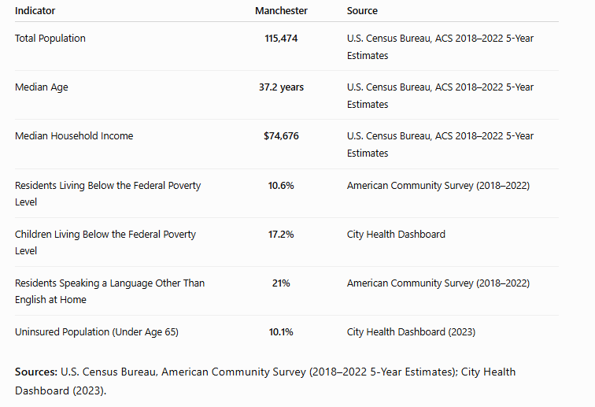

Figure A1. Manchester City Limits & Neighborhood Map
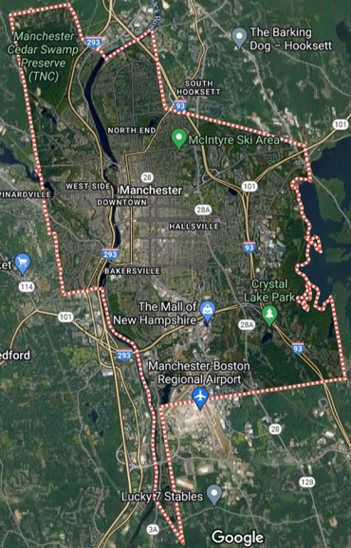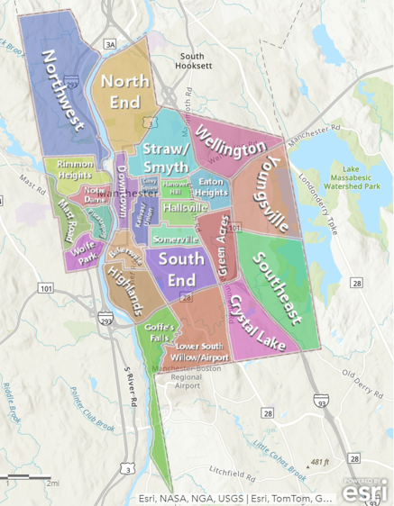

Table A2. Language Spoken at Home
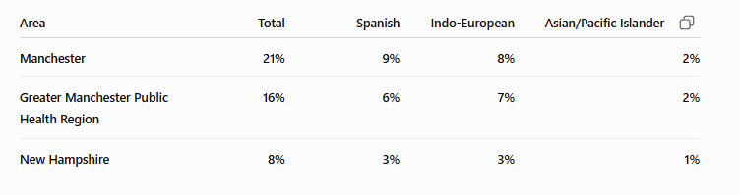
Table A3. Healthcare Access Indicators
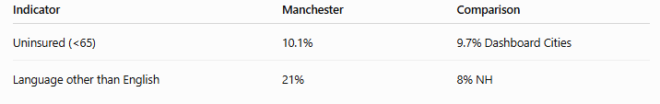

Appendix B. Education
Table B1. Early Childhood Education Indicators

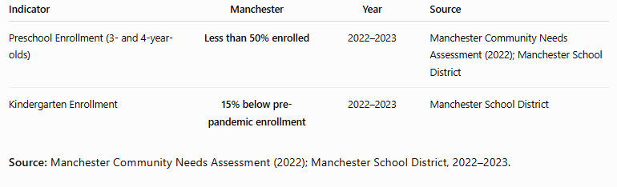
Table B2. Educational Outcomes
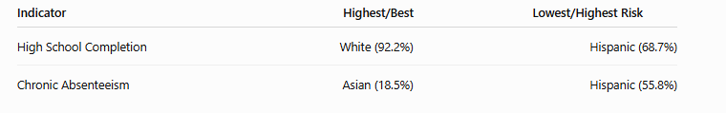

Appendix C. Economic Stability & Food Security
Table C1. Community Poverty Indicators & Economic Indicators
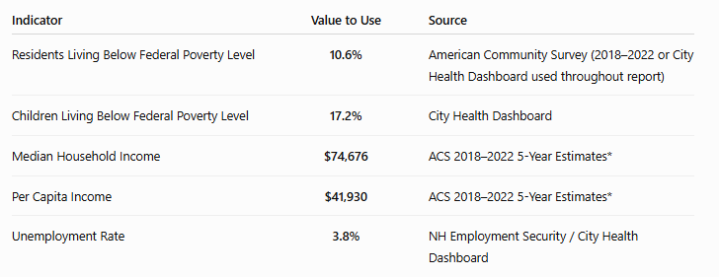

Figure C1. Children Living in Poverty

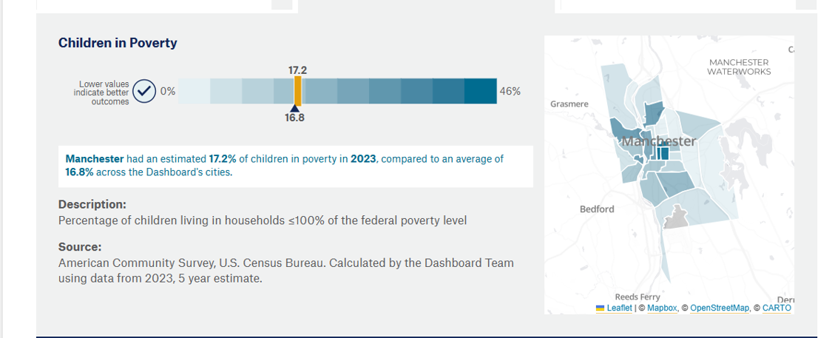

Figure C2. Unemployment

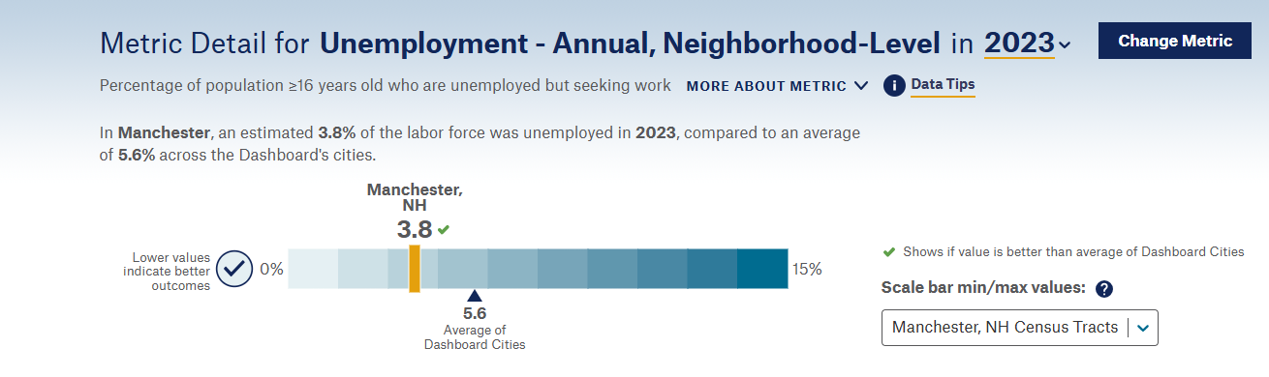
Table C2. Manchester Food and Nutrition Insecurity

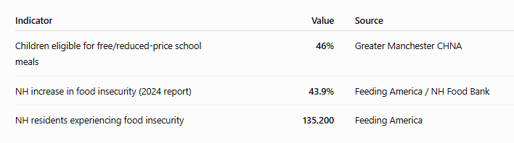

Appendix D. Housing & Transportation

Table D1. Housing Stability Indicators

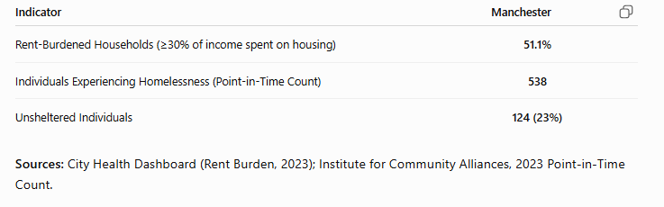

Figure D1. Rent Burden

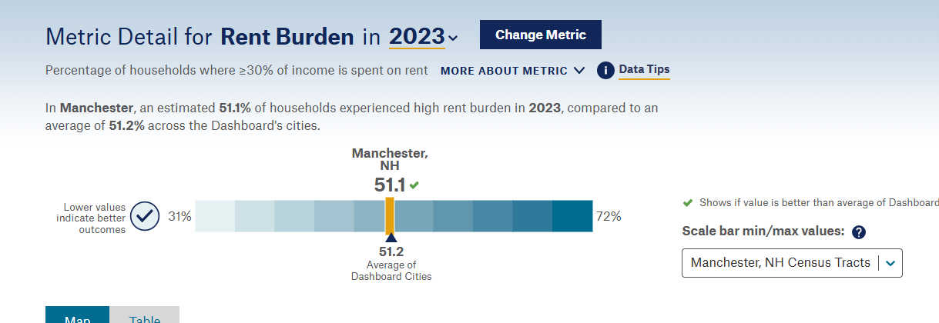

Figure D2. Manchester Homelessness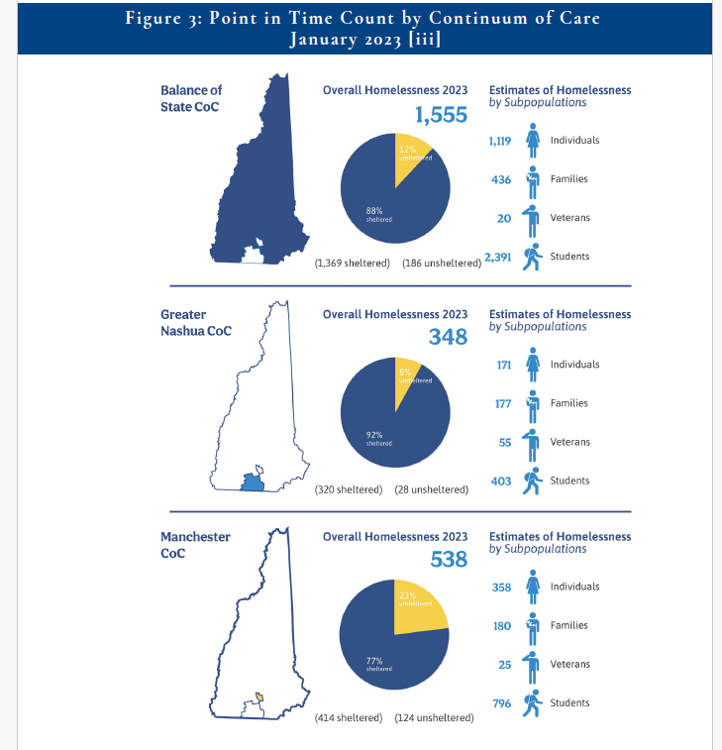

Table D2. Transportation

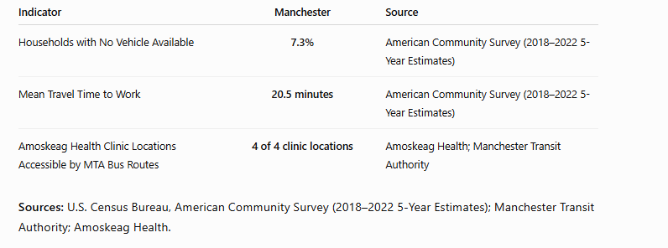

Appendix E – Health Indicator Dashboard

Table E1. Chronic Disease
Indicator | Manchester (2023)
Adult Obesity | 35.0%
Adults with High Blood Pressure | 30.8%
Adults Reporting Physical Inactivity | 25.2%
Adults with Diabetes | 9.4%
Adults Reporting Frequent Physical Distress | 12.5%
Source: City Health Dashboard (2023), CDC PLACES.

Table E2. Behavioral Health Indicators
Indicator | Manchester (2023)
Adults Reporting Frequent Mental Distress | 17.4%
Opioid Overdose Death Rate | 87.9 per 100,000
Source: City Health Dashboard (2023).

Figure E1. Mental Distress

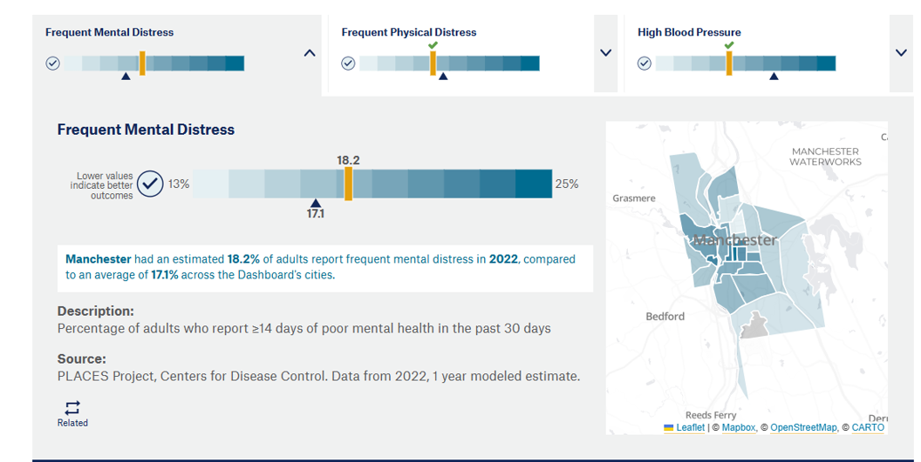

Figure E2. Opioid Overdose Trends

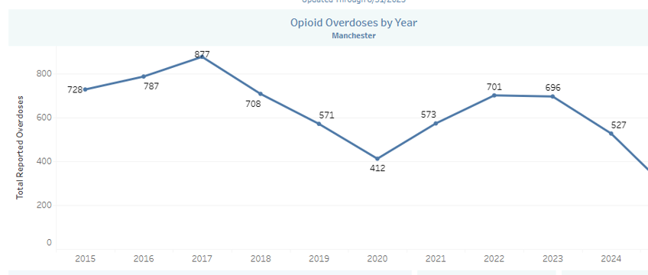

Figure E3. Narcan Administration Map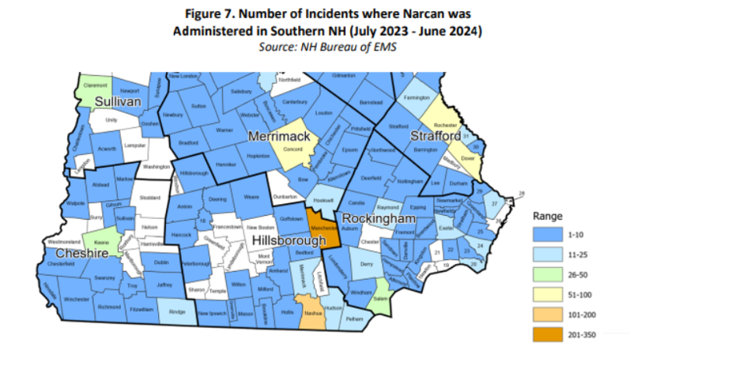

E3 Maternal & Child Health

Table E3.

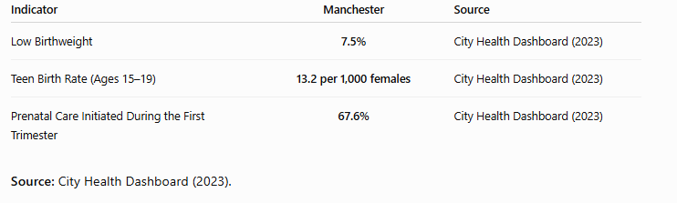

E4 Oral Health

Table E4. Oral Health Indicators

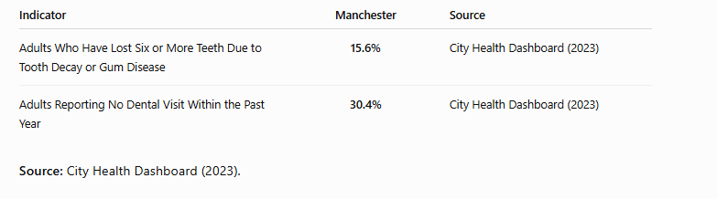

E5. Healthy Aging Indicators

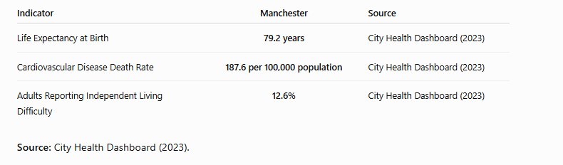

Appendix F Community Safety

Table F1. Community Safety Indicators

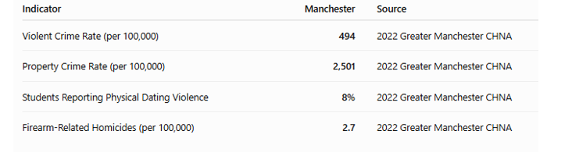

Figure F1. Crime Trend Graph

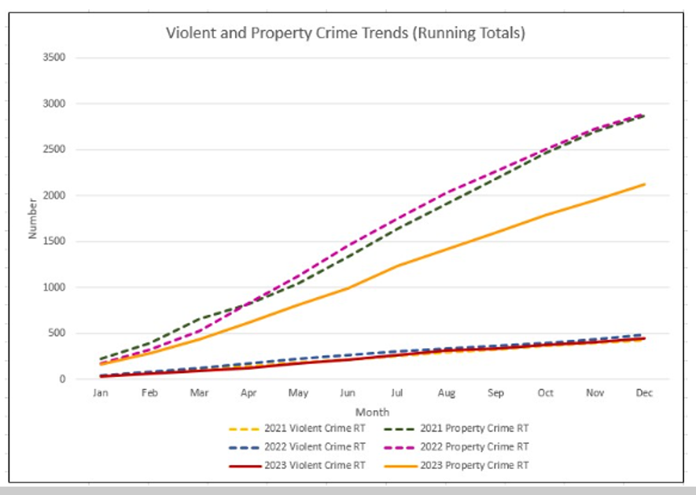

Appendix G. Who We Serve

Table G1. Amoskeag Health Patient Population Overview

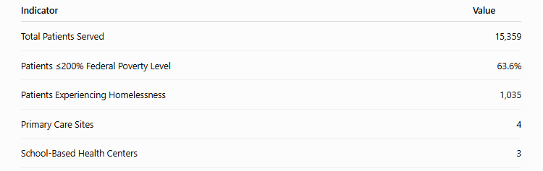

Table G2. Amoskeag Health Patient Income Distribution

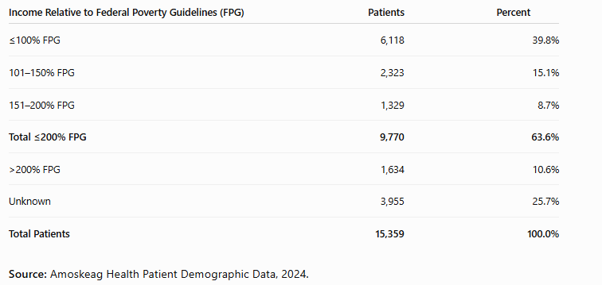

Table G3. Amoskeag Health Patient Insurance Coverage (2024)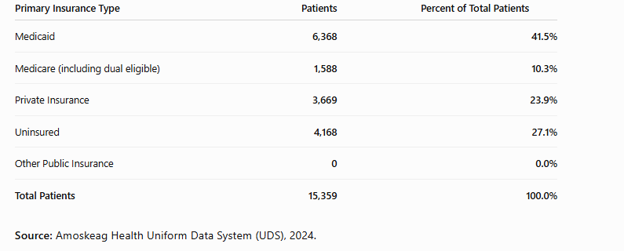
Note: An additional 434 patients were dually eligible for Medicare and Medicaid and are reported separately in the Uniform Data System (UDS). As a result, category totals may not equal the total number of patients.
Table G4. Geographic Distribution of Amoskeag Health Patients by ZIP Code (2024 UDS)

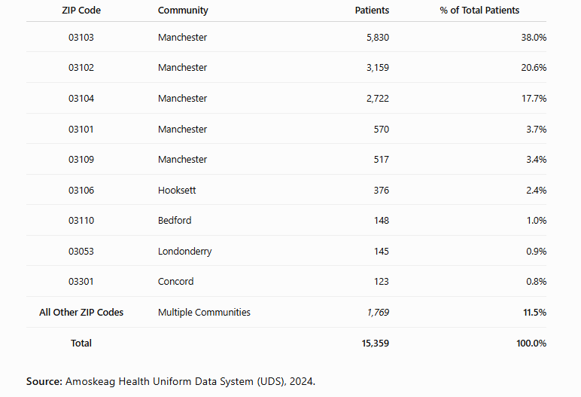

Figure G1. Amoskeag Health Patient Age Distribution (2024)

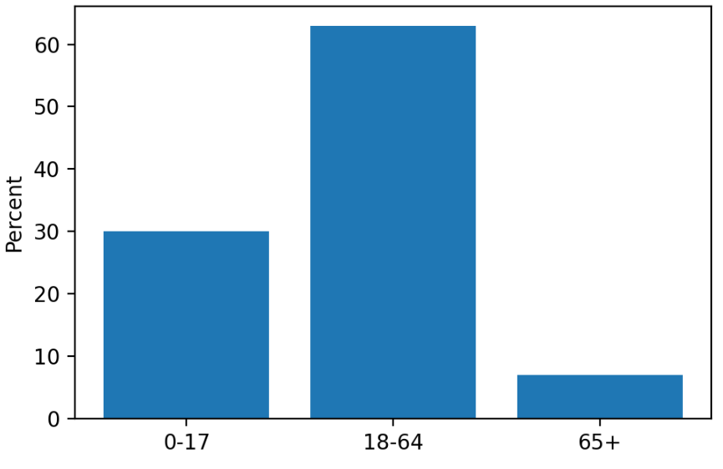

Figure G2. Patient Race/Ethnicity (2024)

